

**Method**

* Eight drinking water samples (500 mL) spiked with native PFAS standards and relevant internals
* Load sample bottles onto system and install cartridges
* Rinse bottles are automatically filled during procedure
* Use positive pressure for pumping solvents and mixes through the system and loading samples
* Condition cartridges with 15 mL 1% methanol followed by 18 mL deionized water
* Load 500 mL samples across the cartridges at 10-15 mL/min
* Rinse sample bottles automatically twice with 7.5 mL DI water and load across cartridges
* Dry cartridges under nitrogen for 5 min
* Rinse sample bottles twice with 4 mL methanol and elute cartridges and collect
* Final extract volume collected is 8 mL

**FMS SuperVap®**

■ Pre-heat temp: 60-65 ºC

■ Pre-heat time: 20 minutes

■ Heat in Time mode at 60-65 ºC under nitrogen (7-10 psi)

■ Reduce to dryness

**Introduction**

Poly- and Perfluoralkyl Substances (PFAS) are compounds primarily composed of or containing a polyfluorinated or perfluorinated carbon chain moiety, such as F(CF2)n- or F(CF2)n-(C2H4)n. PFOS and other PFAS are used in applications including stain-resistant coatings for textiles, leather, and carpets; grease-proof coatings for paper products approved for food contact; firefighting foams; mining and oil well surfactants; floor polishes; and insecticide formulations. In recent years, there has been increasing concern over the presence of PFAS chemicals, such as PFOS (perfluorosulfonate) and PFOA (perfluoro-octanoicacid), in the global environment and their fate and possible effects.

They are classified as emerging pollutants, and the EPA has recently developed methods for their extraction and analysis. These extraction methods outline the use of Solid Phase Extraction (SPE) for drinking water matrix samples employing SDVB cartridges. Consistent with other EPA 500 series methods, EPA 537.1 includes a set of QC and acceptance criteria requiring precise and reproducible analytical practices. Automating these processes can reduce errors and variability associated with manual extractions.

**Instrumentation**

* FMS EconoTrace PFC® System The system is modular in nature and can be extended to a total of 4 modules for a total of 8 samples processed in parallel.
* FMS, Inc, SuperVap-24 Concentrator
* Agilent 6475 TripleQuad LC/MS

**Consumables**

* Agilent PFAS 500 mg DVB cartridges
* Ultrapure DI water
* Methanol pesticide grade
* Relevant PFAS spiking standards

*Application Note*

**Automated Low Background Solid Phase Extraction**

**of Poly- and Perfluoroalkyl Substances in Drinking Water**

**via EPA Method 537.1 - EconoTrace PFC**

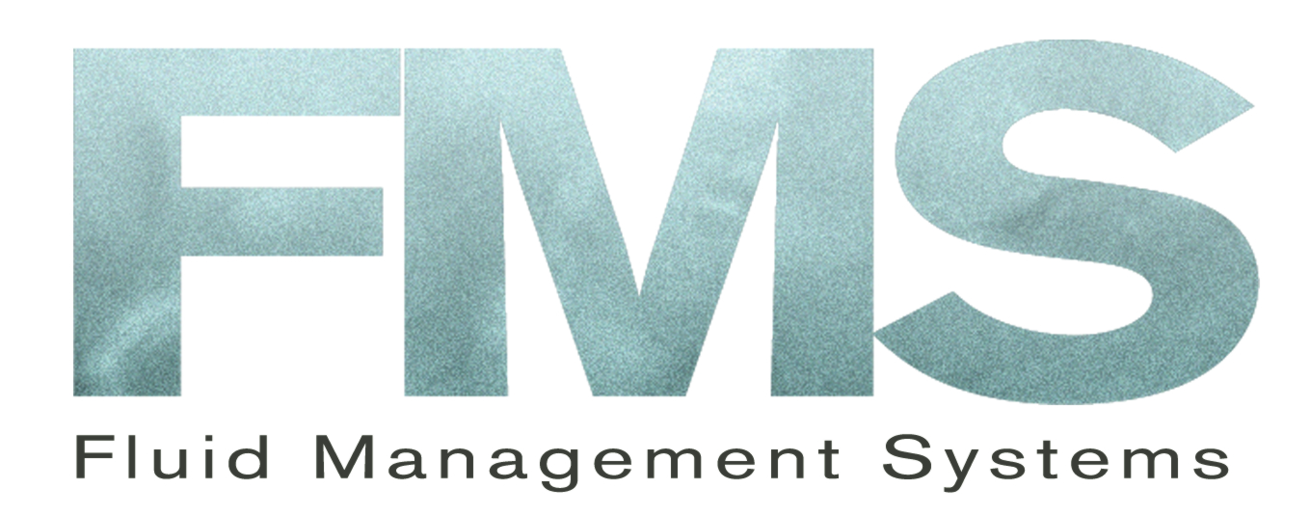



**Analysis**

* Extract is 4 ml times 2, total 8 ml methanol, then concentrated down to dryness. Add 1 ml (96/4) methanol-water.
* Agilent 1290 Infinity II LC System
* Agilent 6475 Triple quad LC/MS
* Agilent Zorbax Eclipse Plus C18 column 2.1 x 50 mm, 1.9 um
* Column temperature 55 oC
* Injection 4.0 uL
* Mobile phase 0.1% Acetic acid in H2 O (A) and methanol (B)
* Gradient:

Stop time 1 minute

* Dynamic MRM negative electrospray
* T (gas) = 300 oC
* T (sheath) = 260 oC

EconoTrace PFC SPE System

*Application note*

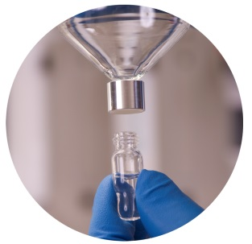

*Application Note*

**Table 1**. Recoveries (%) and RSDs (%) for 18 native PFAS in drinking water (537.1) using EconoTrace PFC (spiked with 20 ng/L).



**Table 3.** Method Detection Limit values (ng/L) for 18 native PFAS in drinking water (537.1) using EconoTrace PFC (spiked with 2.0 ng/L).



**Table 2.** Recoveries (%) and acceptance windows (%) for 4 surrogate PFAS in drinking water (537.1) using EconoTrace PFC (spiked with 10-40 ng/L).





*Application Note*

*Application Note*

**Discussion and Conclusions**

18 native PFAS compounds were analyzed using EPA method 537.1 (Table 1) with the EconoTrace PFC and drinking water. All recoveries were within the acceptance windows of the method with RSDs (%) all < 7%. Run time of the automated system is about 60 min. In agreement with the method the extracts were reduced to dryness followed by reconstitution. The EconoTrace PFC produces very good recoveries with low standard deviations.

Surrogate PFAS recoveries (%) and acceptance windows (%) are shown in Table 2. Excellent data were obtained for the four surrogates well within those windows.

Table 3 shows the Method Detection Limits for all 18 native PFAS using drinking water. Most MDL values are < 0.50 ng/L.

Note that the system has low, non-detect, native background values for PFAS and that the risk of cross-contamination is low (Figure 1). Values are < 0.03 ng/L.

The EconoTrace PFC system produces data that is as good as other more expensive fully automated SPE systems. The system is easy to operate and has fewer valves reducing chance of breakdown and contamination. Cleaning the system between runs is quick and easy. The system, by design, has very low background native PFAS allowing for high throughput analysis of samples without any significant interference.

**Figure 1.** Native PFAS background with EconoTrace PFC for method 537.1 (in ng/L).





*Note*

For more information, contact FMS:

FMS Inc.

900 Technology Park Drive

Billerica MA 01821

Phone: (617) 393-2396

Fax: (617) 393-0194

Email: [onlineinfo@fms-inc.com](mailto:onlineinfo@fms-inc.com)

Web site: www.fms-inc.com



*Application Note*

**Pressurized Liquid Extraction system**

1. Cells filled with hexane: DCM (50:50)
2. Cells pressurized to 1500 PSI
3. Cells heated to 120 ºC (2 cycles, 20 and 10 minutes)
4. Cells cooled to ambient temperature
5. Cells flushed with 20 mL solvent
6. Cells purged with N2 and extract discharged to SuperVap Concentrator.

**SuperVap concentration system**

1. Preheat temp: 20 minutes at 60 °C
2. Evap mode w/Sensor temp: 60 °C
3. Nitrogen Pressure: 10 PSI

**PowerPrep system**

1. Columns conditioned
2. Load sample extract(s)
3. Columns eluted with Hexane and collected (F1)
4. Alumina and Carbon columns eluted with DCM:Hexane and collected (F2)
5. Carbon column rinsed with ETAC:Ben (F3)
6. Carbon column back eluted with Toluene (F4)
7. Fractions F1, F2, F3 collected in a single vessel for the analysis of PCBs and PBDEs
8. Fraction F4 contains PCDDs, PCDFs and Co-Planar PCBs

