

**Procedure**

1 Liter aqueous samples acidified to pH <2 with HCl

Samples spiked with varying concentrations of oil and grease spiking solution.

**SPE**

1. Cartridges conditioned with 15 mL hexane
2. Cartridges conditioned with 15 mL MeOH
3. Cartridges conditioned with 15 mL H2O
4. Samples passed across C18 cartridges at 10-12 inch Hg vacuum
5. Cartridges dried with N2 at 10 PSI
6. Sample bottles sprayed with 80 mL n-hexane
7. N-Hexane bottle spray loaded across cartridge and collected
8. Cartridges eluted with additional   
   10 mL n-hexane
9. Cartridges purged with N2 eluting   
   n-hexane directly to FMS collection tubes

**Gravimetric analysis**

1. Pre-weigh aluminum pan
2. Pour content of collection tube with hexane into weighing pan
3. Evaporate content (hexane) on heating-plate
4. Weigh aluminum pan again and subtract the pre-weight values.

**Introduction**

EPA 1664B refers to the US EPA Solid Phase Extraction (SPE) protocol for n-hexane extractable materials (HEM) - usually oil and grease - from water samples. The method calls for the passage of a 1 Liter aqueous sample across an SPE cartridge, then eluting the cartridge with n-hexane.

The traditional alternative to SPE, LLE (Liquid-Liquid) Extraction, is both time consuming and labor-intensive, and large volumes of solvent. In this automated SPE method, samples are loaded across C18 cartridges and then eluted with less than one quarter of the solvent required for eluting the same sample by LLE.

The following application covers the extraction of aqueous samples using the FMS, Inc Turbo Trace system to extract aqueous samples for EPA 1664B.

**Instrumentation**

• FMS, Inc. TurboTrace® SPE system

• FMS, Inc. 250 mL concentrator tubes

• Mettler Toledo analytical balance

**Consumables**• FMS Inc 2-gram C18 Cartridges

* Fisher hexadecane and stearic acid
* Fisher 6 N Hydrochloric Acid
* Fisher Optima* n-Hexane
* Fisher Optima* Methanol
* Ultrapure DI water
* Fisher Oil & Grease aluminum weighing pans

**EPA 1664B Oil and Grease by**

**Automated Solid Phase Extraction (SPE)**

***Application Note***



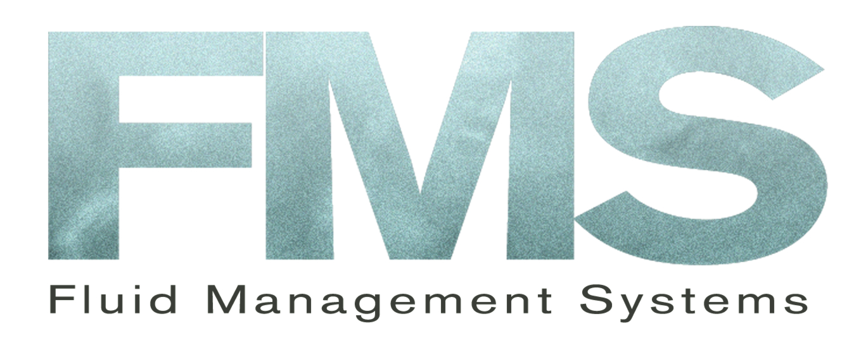

**Conclusions**

Analysis of oil and grease yielded excellent, consistent recoveries with minimal deviations between replicates.

Extractions at 2.5, 5,10, 20 and 40 mg/L all displayed excellent recoveries within 78-114% windows.

With a total of 90 mL n-hexane required for the elution and bottle rinse combined with a total extraction time of < 60 min from start to elution, the Turbo Trace SPE proves to be a more efficient and economical solution for EPA1664B extractions than LLE.

Combined with gravimetric analysis, minimal sample manipulation is needed, eliminating recovery loss by human interaction.

**Results**

|  |  |  |  |  |  |
| --- | --- | --- | --- | --- | --- |
| **Sample** | **Amount** | |  | |  |
| **Concentration** | **Recovered (%)** | |  | |  |
|  |  | |  | |  |
| 2.5 mg/L  2.5 mg/L  5 mg/L  5 mg/L  10 mg/L | 95%  95%  85%  95%  85% |  | |
| 10 mg/L | 90% |
|  |  |  | |
| 20 mg/L | 85% |  | |
| 20 mg/L | 85% |
|  |  |  | |
| 40 mg/L | 90% |  | |
| 40 mg/L | 95% |

FMS TurboTrace SPE system

*Table 1; Results of oil and grease LCS samples   
at five concentrations.*



For more information contact FMS:

FMS Inc.

900 Technology Park Dr

Billerica, MA 01821

Phone: (617) 393-2396

Fax: (617) 393-0194

Email: onlineinfo@fms-inc.com

Web site: www.fms-inc.com

***Application Note***

